**SonarQube Analysis**

**Pre-requisites:**

1. Java JDK 1.8 or above installed
2. Apache Maven 3.3.9 or above installed

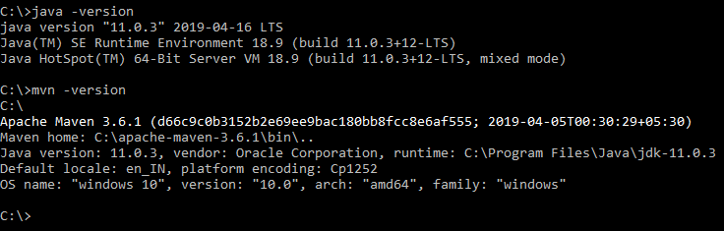

1. A Java project created with Maven configurations.

**Downloading and installing Sonarqube**

Download the Sonarqube latest version (7.7) from the following link:

<https://binaries.sonarsource.com/Distribution/sonarqube/sonarqube-7.7.zip>

Extract it and store the extracted Sonarqube 7.7 folder in convenient path.

**Start the Sonarqube server**

1. Open the command line and go to the following path:

**Cd {path to the Sonarqube}/bin/windows-x86-64**

1. Execute the StartSonar.bat file

**SonarStart.bat**

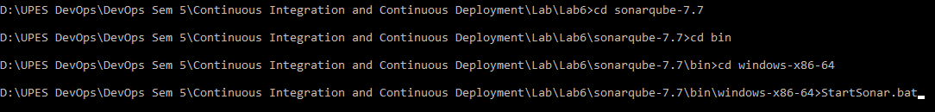

Wait for some time for the Sonarqube to load up fully.

Visit **localhost:9000** on the web browser to open SonarQube server.

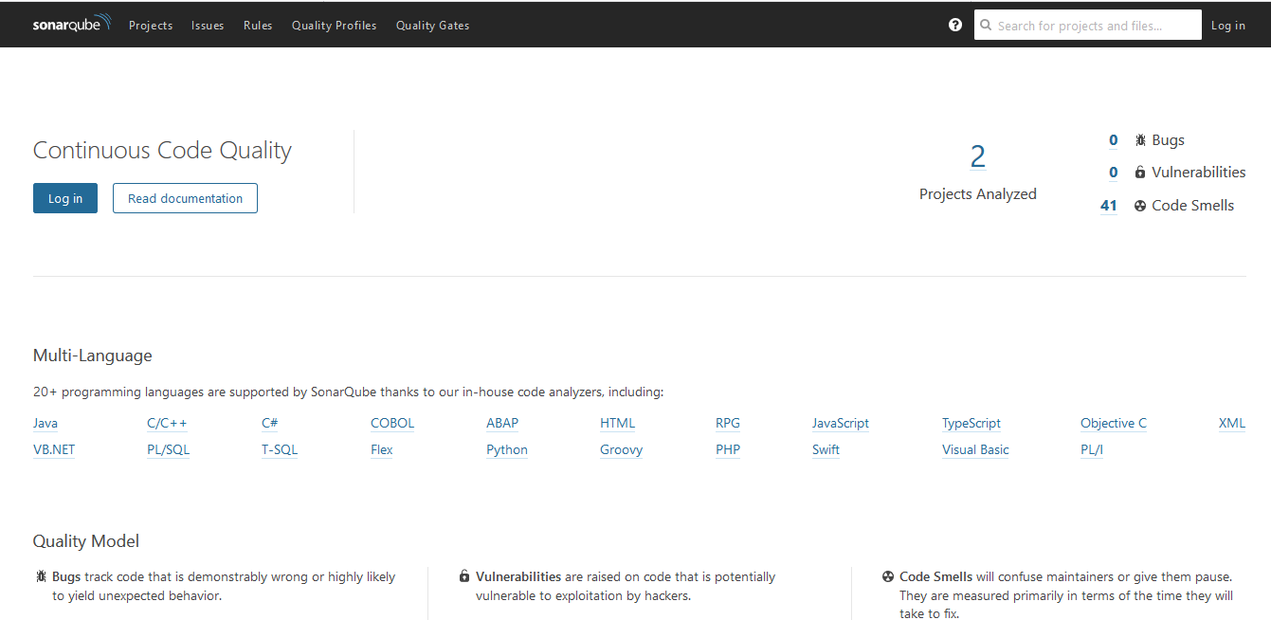

1. Click on Login Page and enter the default username **admin** and default password **admin.**

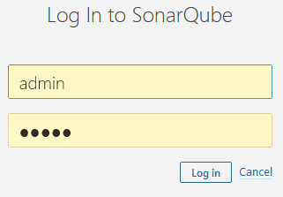

The homepage of the admin user opens up.

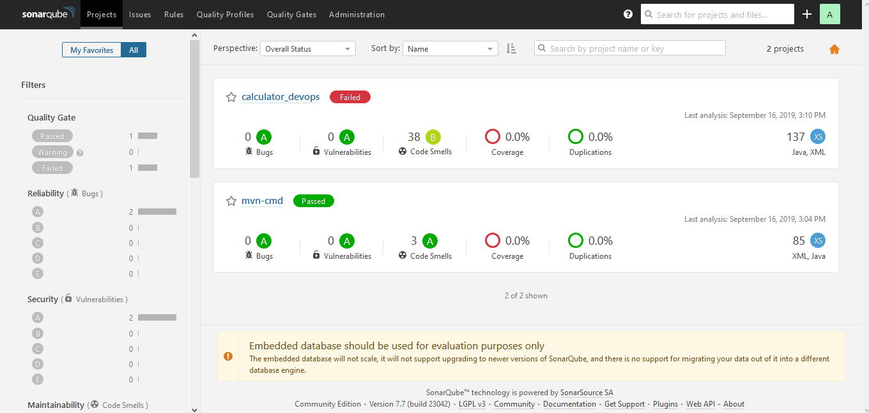

**Create a SonarQube report for a Maven Project:**

1. Go to a Maven project root directory where POM.xml file is stored.

Here, we use our Maven-Using-CMD project:

<https://www.github.com/NishkarshRaj/Maven-Using-CMD>

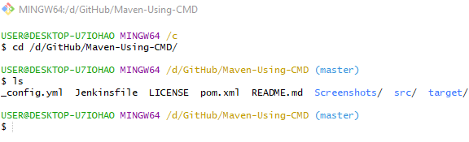

1. On the command line, type the following command:

**mvn clean install sonar:sonar -Dsonar.host.url=http://localhost:9000 -Dsonar.analysis.mode=publish**

It will automatically monitor the Maven project and publish the reports to SonarQube.

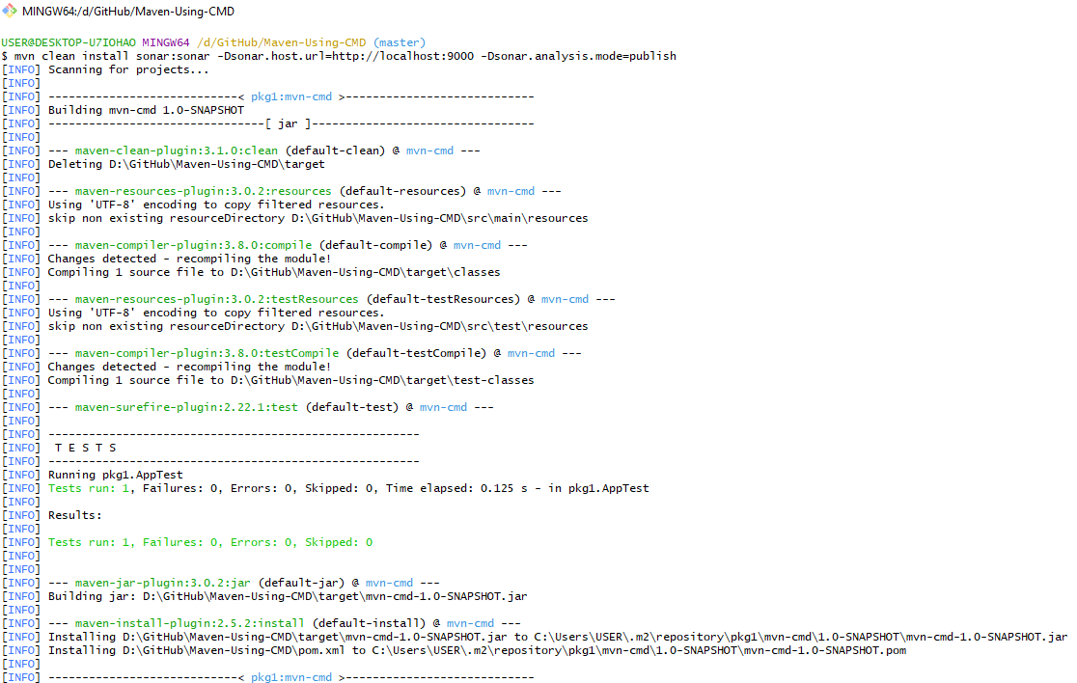

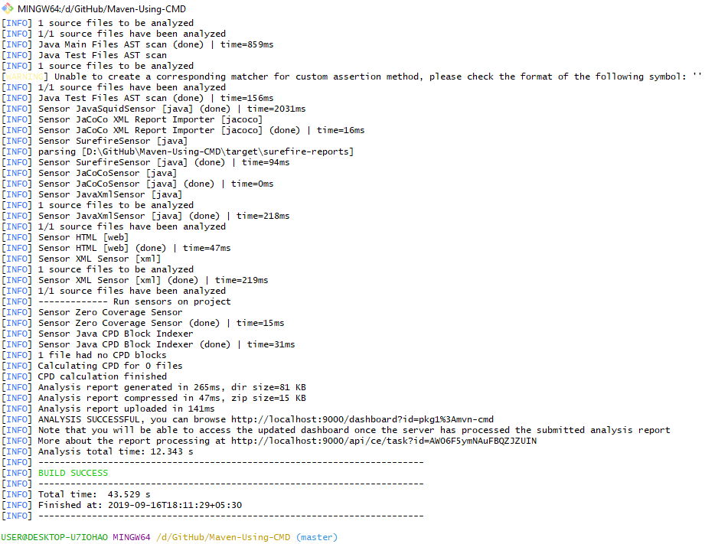

1. Go to SonarQube server to see the final report:

